USE TSQL;

GO

--Task 1: Write a Basic TRY/CATCH construct

SELECT CAST(N'Some text' AS int);

--Detyra 1: Shkruaj nje konstruktor bazike TRY/CATCH

SELECT CAST(N'Some text' AS int);

Create procedure printText

as

BEGIN

BEGIN TRY

SELECT CAST(N'Some text' AS int)

End TRY

Begin CATCH

SELECT

ERROR_MESSAGE() AS ErrorMessage,

ERROR_SEVERITY() AS ErrorSeverity,

ERROR_STATE() AS ErrorState,

ERROR_LINE() AS errorLine,

ERROR_NUMBER() AS errorNumber,

ERROR_PROCEDURE() AS errorProcedure

END CATCH

END

go

Commands completed successfully.

Completion time: 2024-08-28T19:57:33.5943992+02:00

EXEC printText

GO

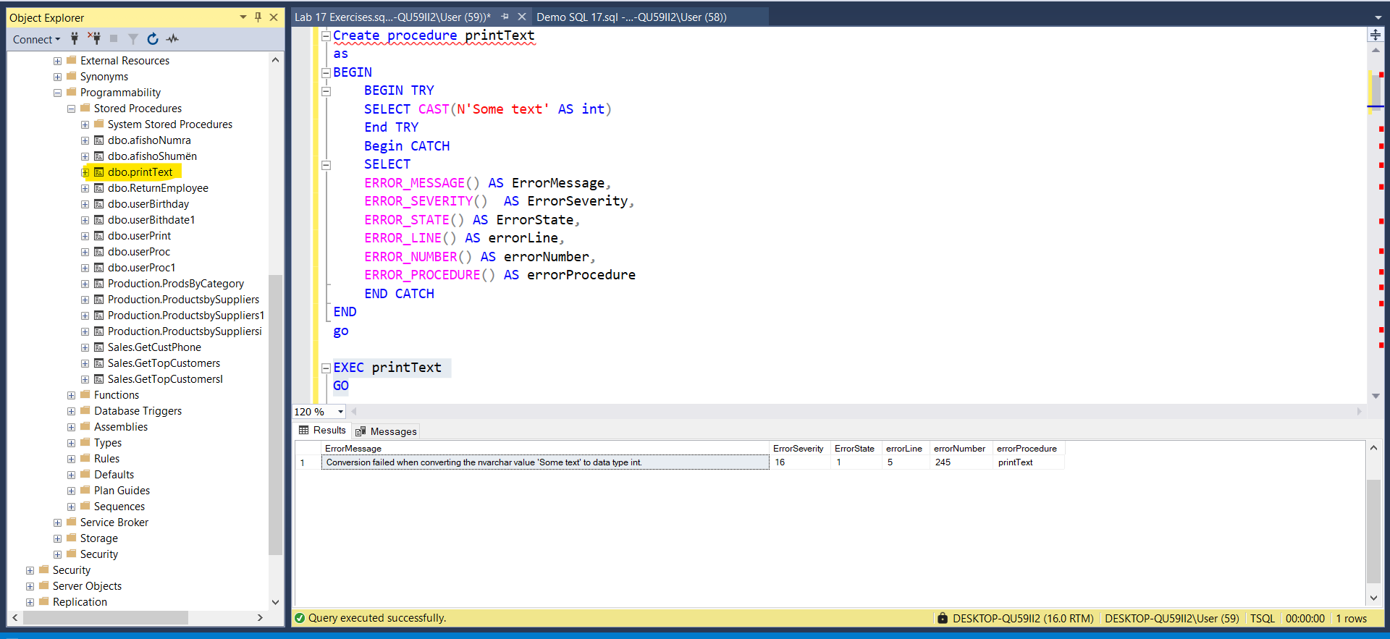

--Task 2: Display an error number and an error message

CREATE PROCEDURE printNum(@num varchar(20) ='0')

as Begin

BEGIN TRY

PRINT (5. / CAST(@num AS numeric(10,4)));

END TRY

BEGIN CATCH

Select

ERROR_NUMBER() errNumber,ERROR_MESSAGE() as errMessage

END CATCH

END

GO

Commands completed successfully.

Completion time: 2024-08-28T20:08:17.5551171+02:00

EXEC printNum

GO

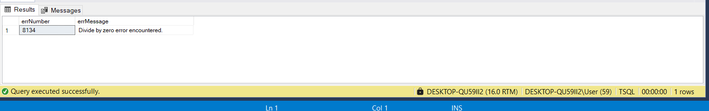

--Task 3: Add conditional logic to a CATCH block

CREATE PROCEDURE printNumaa(@num varchar(20) = 'A')

as

BEGIN

BEGIN TRY

DECLARE @num1 as INT = (5. / CAST(@num AS numeric(10,4)));

IF(@num1>0)

Begin

PRINT @num1 ;

End

ELSE

BEGIN

PRINT N''

END

END TRY

BEGIN CATCH

PRINT 'Error Number: ' + CAST(ERROR_NUMBER() AS varchar(10));

PRINT 'Error Message: ' + ERROR_MESSAGE();

END CATCH

END

GO

Commands completed successfully.

Completion time: 2024-08-28T20:27:11.6972878+02:00

exec printNumaa

go

Error Number: 8114

Error Message: Error converting data type varchar to numeric.

Completion time: 2024-08-28T20:28:03.0628228+02:00

--Task 4: Execute a stored procedure in the CATCH block

--Create Procedure

CREATE PROCEDURE dbo.GetErrorInfo

AS

Begin

BEGIN TRY

DECLARE @num varchar(20),@numInt int ;

SET @num = '0'

SET @numInt = (5. / CAST(@num AS numeric(10,4)))

PRINT @numInt;

END TRY

BEGIN CATCH

PRINT 'Error Number: ' + CAST(ERROR_NUMBER() AS varchar(10));

PRINT 'Error Message: ' + ERROR_MESSAGE();

PRINT 'Error Severity: ' + CAST(ERROR_SEVERITY() AS varchar(10));

PRINT 'Error State: ' + CAST(ERROR_STATE() AS varchar(10));

PRINT 'Error Line: ' + CAST(ERROR_LINE() AS varchar(10));

PRINT 'Error Proc: ' + COALESCE(ERROR_PROCEDURE(), 'Not within procedure');

END CATCH

End

GO

Commands completed successfully.

Completion time: 2024-08-28T20:37:28.9317380+02:00

EXECUTE dbo.GetErrorInfo

GO

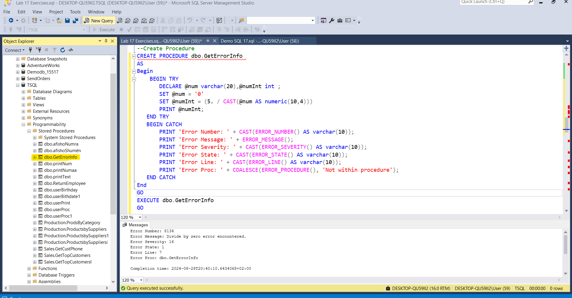

--Task 1: Re-throw the existing error back to a client

Create Procedure reThrowError(@num varchar(20),@numInt int OUTPUT)

AS

BEGIN

BEGIN TRY

SET @numInt = (5. / CAST(@num AS numeric(10,4)))

PRINT @numInt

END TRY

BEGIN CATCH

Print N'An Error occurred'+'---- ' + ERROR_MESSAGE() ;

THROW;

END CATCH;

END

GO Commands completed successfully.

Completion time: 2024-08-28T21:34:10.6022422+02:00

DECLARE @a1 varchar(20) = '0',@num1 int

EXEC reThrowError @num = @a1,@numInt = @num1 OUTPUT

Select @a1 as teksti , @num1 as result

GO

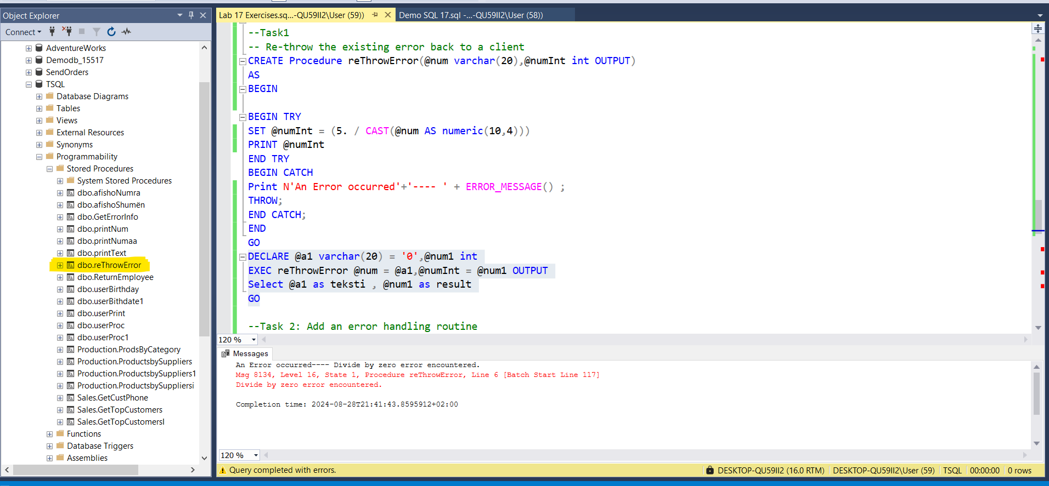

--Task 2: Add an error handling routine

create procedure GetError(@num varchar(20),@numInt int OUTPUT)

AS

BEGIN

BEGIN TRY

IF(@@ERROR>8134)

BEGIN

SET @numInt = (5. / CAST(@num AS numeric(10,4)))

PRINT N'Handling division by zero...';

End

Else

BEGIN

PRINT N'Throwing original Error'

End

END TRY

BEGIN CATCH

Print N'An Error occurred'+'---- ' + ERROR_MESSAGE() ;

throw;

END CATCH;

END

GO

Commands completed successfully.

Completion time: 2024-08-28T22:07:41.2742378+02:00

DECLARE @a1 varchar(20) = '0',@num1 int

EXEC GetError @num = @a1,@numInt = @num1 OUTPUT

Select @a1 as teksti , @num1 as result

GO

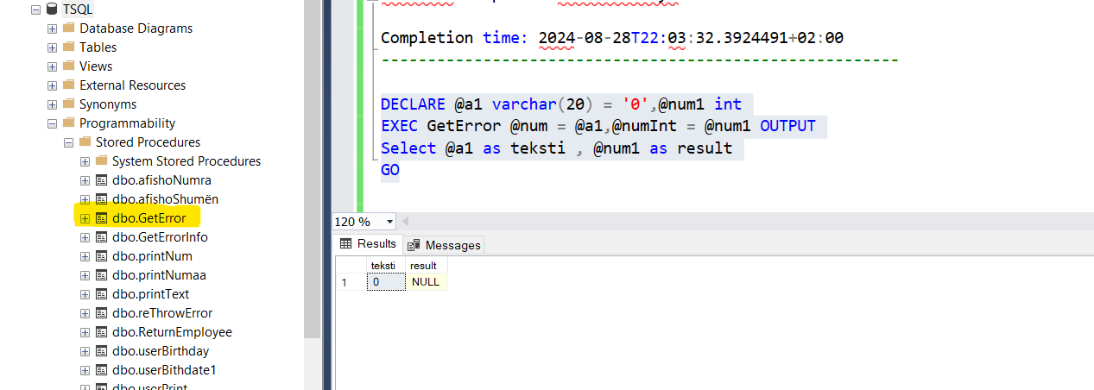

-----------------------

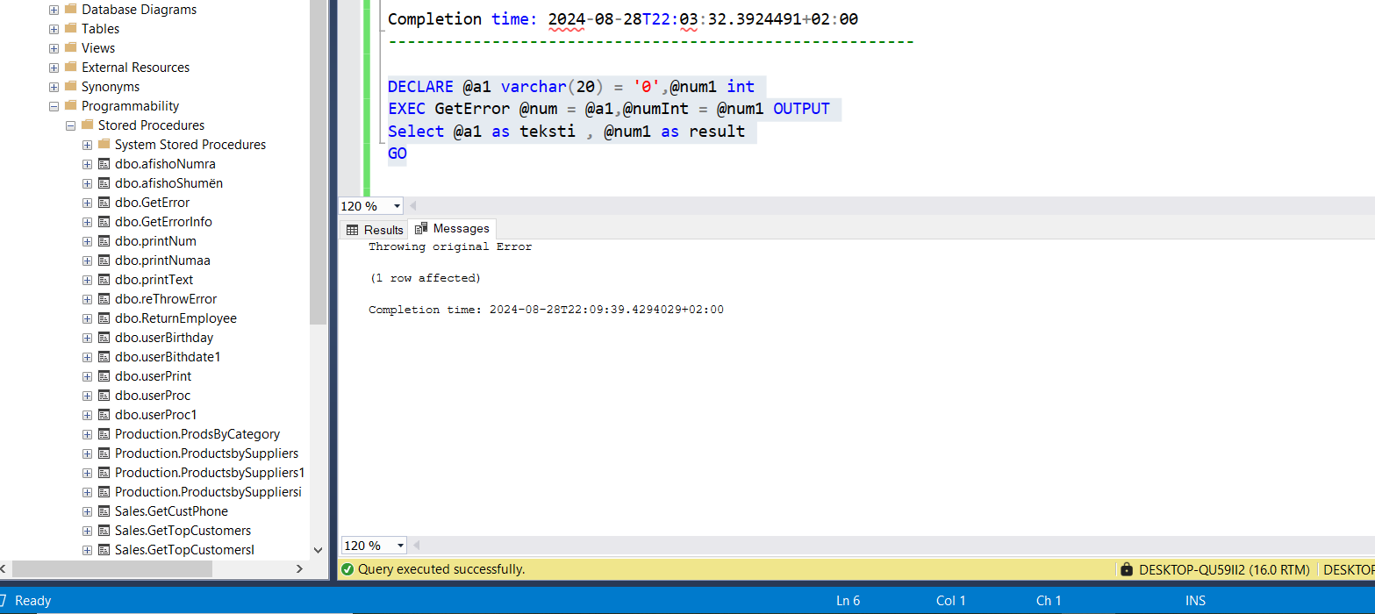

--Task 3: Add a different error handling routine

DECLARE @msg NVARCHAR(2048) = FORMATMESSAGE(N'You are doing the exercise for Module 17 on ' +

FORMAT(CURRENT_TIMESTAMP, 'MMMM d, yyyy', 'en-US') +

'.It''s not an error but it means that you are near the final module!');

THROW 50001, @msg,1

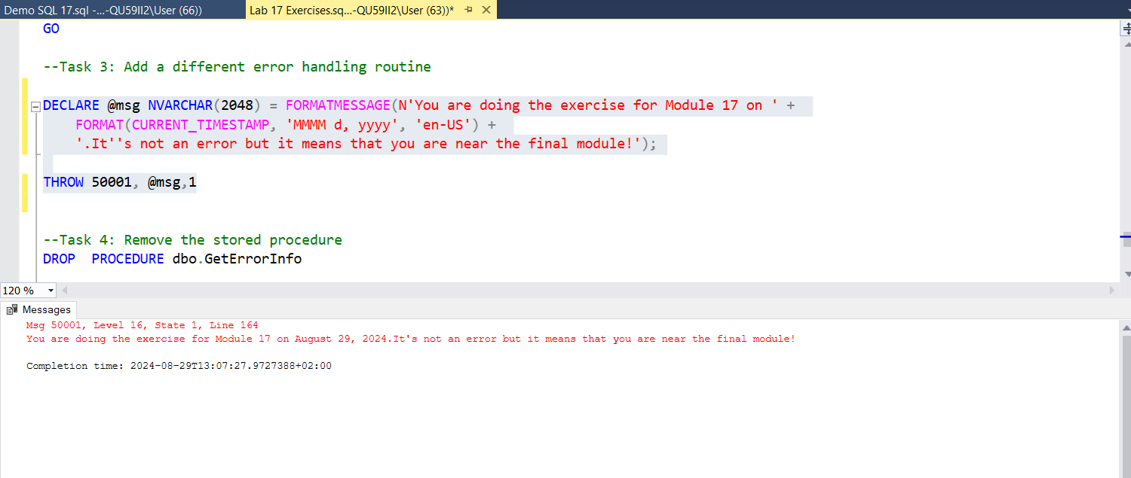

--Task 4: Remove the stored procedure

DROP PROCEDURE dbo.GetErrorInfo

Commands completed successfully.

Completion time: 2024-08-29T13:09:36.4625659+02:00